create table branch

(

branch_name varchar(10),

branch_city varchar2(10),

assets real,

primary key(branch_name)

);

create table accounts

(

accno number(4),

branch_name varchar2(10),

balance real,

primary key(accno),

foreign key(branch_name) references branch(branch_name)

);

create table customer

(

customer_name varchar2(20),

customer_street varchar2(20),

customer_city varchar2(20),

primary key(customer_name)

);

create table depositor

(

customer_name varchar(10),

accno number(5),

primary key(customer_name, accno),

foreign key(customer_name) references customer(customer_name),

foreign key(accno) references accounts(accno)

);

create table loan

(

loan_number number(5),

branch_name varchar2(10),

amount real,

primary key(loan_number),

foreign key(branch_name) references branch(branch_name) on delete cascade

);

create table borrower

(

customer_name varchar2(10),

loan_number number(5),

primary key(customer_name),

foreign key(customer_name) references customer(customer_name),

foreign key(loan_number) references loan(loan_number)

);

insert into branch values ('&branch_name', '&branch_city', &assets);

insert into accounts values (&accno, '&branch_name', &balance);

insert into customer values('&customer_name', '&customer_street', '&customer_city');

insert into depositor values ('&customer_name', &accno);

insert into loan values(&loan_number,'&branch_name', &amount);

insert into borrower values('&customer_name', &loan_number);

select *from branch

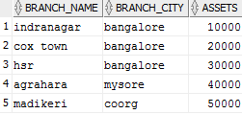

select *from accounts

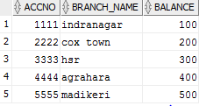

select *from customer

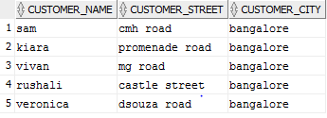

select *from depositor

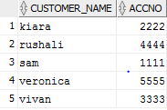

select *from loan

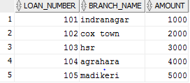

select *from borrower

